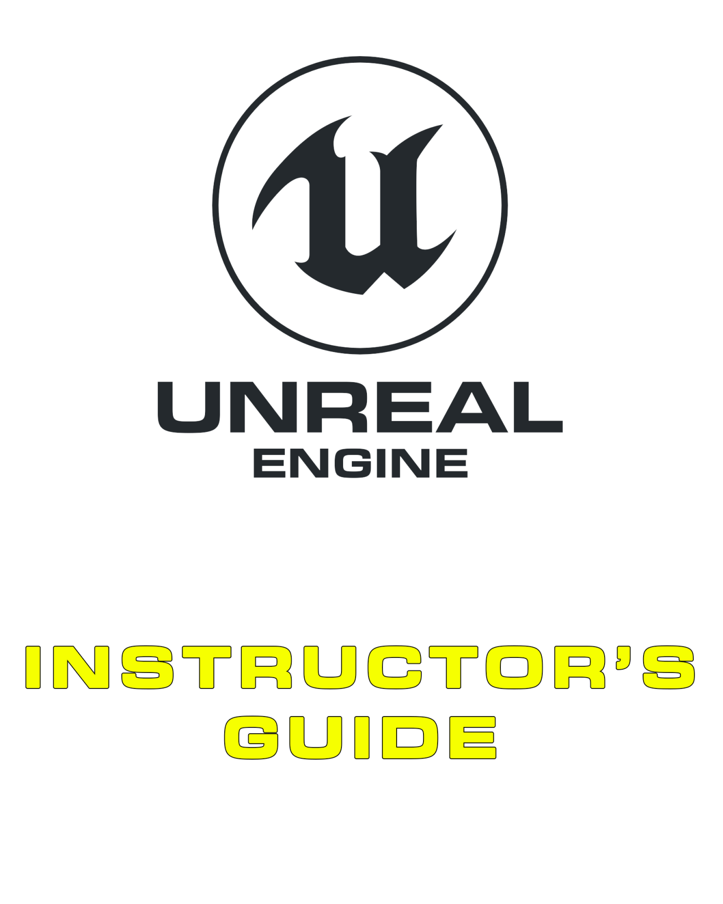

04 Level Design

Contents

[Overview 3](#_Toc508201291)

[4.1. Level Design Overview 4](#_Toc508201292)

[White-Rooming 4](#_Toc508201293)

[Meshing 4](#_Toc508201294)

[Lighting 4](#_Toc508201295)

[Polish 5](#_Toc508201296)

[4.2. Testing and Iteration 5](#_Toc508201297)

[4.3. Worlds versus Levels 5](#_Toc508201298)

[4.4. Level Design Patterns and Tropes 5](#_Toc508201299)

[Periodical Encounters 5](#_Toc508201300)

[Bait and Lures (Risk/Reward Paths) 5](#_Toc508201301)

[Monster Closets 6](#_Toc508201302)

[The Traveled Path 6](#_Toc508201303)

[Environmental Alternatives 6](#_Toc508201304)

[Exercises 7](#_Toc508201305)

[Exercise 4A: Analyzing an Existing Level 7](#_Toc508201306)

[Exercise 4B: Crafting a Level (White-Rooming) 9](#_Toc508201307)

# Overview

**PURPOSE**

The purpose of this tutorial is to cover the analysis and practice of level design within the context of computer games.

**SCOPE**

This section will provide an introductory overview of the following:

* Level analysis
* White-rooming
* Types of levels
* Common level ‘tropes’

**PREREQUISITES**

* An Epic Games account
* A copy of Unreal Engine 4
* A basic understanding of the Engine and how to use the Editor
* A practical understanding of Blueprint

## 4.1. Level Design Overview

### White-Rooming

A white room is an environment developed as a simple, clean, test version of a level that can be quickly tested and iterated upon that is typically constructed from BSP Brushes.

This version of the environment is generally devoid of any aesthetic influence and, in the case of single-player games, often developed so that it can be reappropriated for different points in the game’s narrative.

Once a white room is ready for initial testing, a wide range of potential changes need to be made. Following are just a few examples:

* Base-level lighting and coloring will need to be added to guide players through the map. In the final aesthetic pass, similar indicators will also need to be added to the map. Low-level fog is another commonplace addition, as it helps aid in depth perception and environment readability.
* A puzzle or level mechanic that doesn’t “work” in one environment may still be duplicated and reused in another environment.
* Creating multiple versions of a white room for testing in quick succession can be advantageous in comparing slight changes; however, be aware that testers may be best exposed to these changes in variables orders and inadvertently compromise test data.

### Meshing

After white-rooming has been completed and the level is beyond the primary testing phase, the next thing to do is begin meshing the environment. This process involves adding Static Meshes to add detail and apply a particular theme to the environment.

Before this phase begins, it’s typical either to have concept art made or to use existing asset kits to develop the look of the map to be consistent with the look of existing levels in the game.

### Lighting

In the lighting pass, the final lights are placed throughout the level. These lights will have their settings tweaked to match the final desired look and feel of the level, rather than simply serving to provide basic illumination. Post process effects are also adjusted at this stage, again to match the final look and feel of the level.

The changes in the lighting and post process effects may mean that changes to the materials applied throughout the level are also necessary. Finally, some particle effects may be added to the level. For instance, if the lighting in a level is done with torches, the particle effects for the torch flames can be added during this pass.

### Polish

The polish pass is the point where any finishing touches are added to the level and minor changes are made throughout the environment. Effects, Reflection Capture Actors, and any other final meshes or lighting can be added to the level.

## 4.2. Testing and Iteration

Testing and QA should not be restricted to any individual phase of development. Throughout production, testing and iteration should be an ongoing process to refine the player experience.

## 4.3. Worlds versus Levels

Depending on the intended play experience, it’s common for development studios to focus on developing open-world experiences over traditional, more linear environments. In this situation, multiple level designers typically work together to craft an environment that allows for certain play experiences to potentially occur.

|  |  |
| --- | --- |
| Open World | Level Based |
| * *Fortnite* * *Fallout* * *The Legend of Zelda: Breath of the Wild* * *Skyrim* * *PlayerUnknown’s Battlegrounds* * *Sunset Overdrive* | * *Gears of War* * *Half-Life* * *Mario* * *Ratchet & Clank* * *Crash Bandicoot* * *Unreal Tournament* |

## 4.4. Level Design Patterns and Tropes

### Periodical Encounters

Staging levels such that players go from brief intense periods of combat to periods of quiet in a cyclical fashion is a common technique. In games that use health regeneration, this approach allows level designers to know the minimum condition of a player before they enter a fight.

### Bait and Lures (Risk/Reward Paths)

Health, weapons, and other items can be used as a way to encourage a player to stray from a safe region for various rewards. Often this bait can be used as a method of encouraging exploration or forcing the player to consider their state (for example, being low on health or ammo).

### Monster Closets

“Monster closets” are used to place enemies (often monsters) throughout an environment without them seeming to teleport into the map. Sometimes they can be used to justify the enemies’ existence (such as enemies coming from a “security door”) or as a method of scaring a player by having areas near them suddenly pop open with enemies. Having the latter occur intermittently may lead to generating distrust in the environment, which may or may not be desirable.

### The Traveled Path

To lead a player in a particular direction, it’s common to simulate a character having passed through the way the player is going. An example would be simulating the path taken by a prisoner that escaped from an environment the player is in. Naturally the player will follow the path left behind the prisoner. These traveled paths can also serve as a way of telling subtle stories about the world or hinting at things to come.

### Environmental Alternatives

When a player is presented with a number of opponents, a designer may choose to build into the environment a method to circumvent the engagement—for example, an airlock to unlock, a security door to open, or reinforcements that can be called in. Often these environmental alternatives are tied to abilities the player has unlocked, though this is not a requirement.

## 4.5 Supplementary Resources

You will need these files to complete the Exercises on this page. These files are hosted on the Unreal Engine Marketplace and can be accessed from your Launcher by following the directions below.

1. On the [Code Redemption tab](https://www.unrealengine.com/dashboard/code-redemption" \t "_blank) (<https://www.unrealengine.com/dashboard/code-redemption>) of your Epic personal dashboard, enter the code RXM24-3UWY3-8EFPJ-QNTCN, then click REDEEM and CONFIRM  
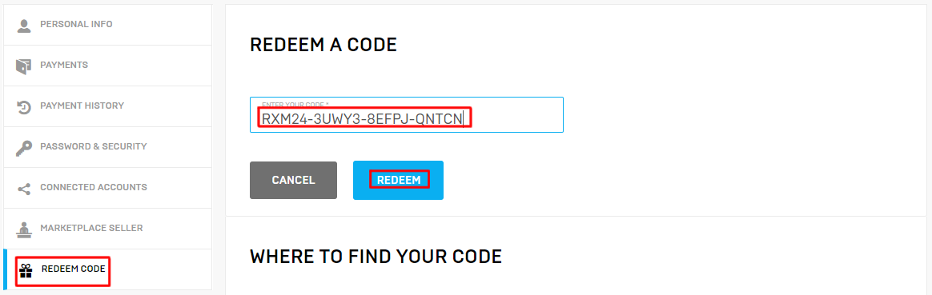

2. Open the Epic Games Launcher (you can download the [Launcher](https://www.unrealengine.com/download" \t "_blank) [here](https://www.unrealengine.com/download)if you need it), navigate to the Vault section of the Unreal Engine Library tab, and click Create Project on Academic Examples or Bird of Prey  
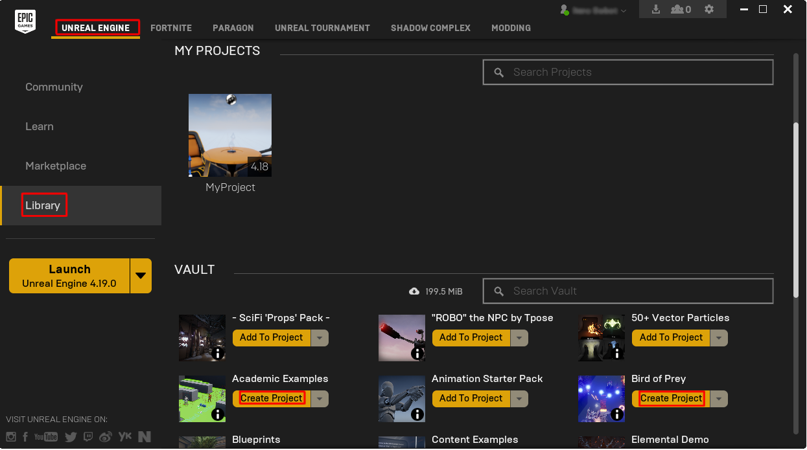  
  
3. Choose a project name and location and click Create  
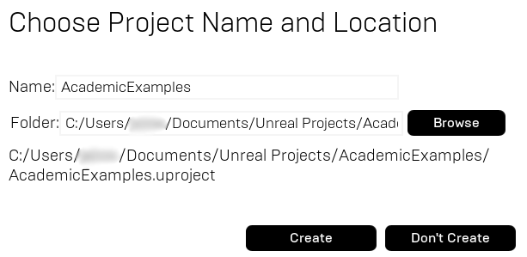

And that's it! If you have any further questions about how to download these products from the Epic Games Launcher, please contact [marketplace-support@unrealengine.com](mailto:marketplace-support@unrealengine.com" \t "_blank).

# Exercises

## Exercise 4A: Analyzing an Existing Level

**Deliverables:** Activity sheet (see below), In-class observation

**Instructor Task:** Have the students break into small groups and assign each group to a level/map from one of the popular games below:

* *Mario Kart* (Rainbow Road)
* *Counter-Strike* (Dust 2)
* *Unreal Tournament 3* (Facing Worlds)
* *Call of Duty* (Nuketown)
* *Halo* (Blood Gulch map)
* *Tomb Raider* (2013 onward)
* *PlayerUnknown’s Battlegrounds*
* *Fortnite: Battle Royale*

**Student Task:** Form into groups and discuss the design aspects of your assigned level. Summarize your findings in the activity sheet.

Activity Sheet 4A

|  |  |  |  |
| --- | --- | --- | --- |
| Name: |  | Date: |  |

Level Analysis (Summarize your findings in the space below.)

\_\_\_\_\_\_\_\_\_\_\_\_\_\_\_\_\_\_\_\_\_\_\_\_\_\_\_\_\_\_\_\_\_\_\_\_\_\_\_\_\_\_\_\_\_\_\_\_\_\_\_\_\_\_\_\_\_\_\_\_\_\_\_\_\_\_\_\_\_\_\_\_\_\_\_\_\_\_\_\_\_\_\_\_\_\_\_\_\_\_\_\_\_\_\_\_\_\_\_\_\_\_\_\_\_\_\_\_\_\_\_\_\_\_\_\_\_\_\_\_\_\_\_\_\_\_\_\_\_\_\_\_\_\_\_\_\_\_\_\_\_\_\_\_\_\_\_\_\_\_\_\_\_\_\_\_\_\_\_\_\_\_\_\_\_\_\_\_\_\_\_\_\_\_\_\_\_\_\_\_\_\_\_\_\_\_\_\_\_\_\_\_\_\_\_\_\_\_\_\_\_\_\_\_\_\_\_\_\_\_\_\_\_\_\_\_\_\_\_\_\_\_\_\_\_\_\_\_\_\_\_\_\_\_\_\_\_\_\_\_\_\_\_\_\_\_\_\_\_\_\_\_\_\_\_\_\_\_\_\_\_\_\_\_\_\_\_\_\_\_\_\_\_\_\_\_\_\_\_\_\_\_\_\_\_\_\_\_\_\_\_\_\_\_\_\_\_\_\_\_\_\_\_\_\_\_\_\_\_\_\_\_\_\_\_\_\_\_\_\_\_\_\_\_\_\_\_\_\_\_\_\_\_\_\_\_\_\_\_\_\_\_\_\_\_\_\_\_\_\_\_\_\_\_\_\_\_\_\_\_\_\_\_\_\_\_\_\_\_\_\_\_\_\_\_\_\_\_\_\_\_\_\_\_\_\_\_\_\_\_\_\_\_\_\_\_\_\_\_\_\_\_\_\_\_\_\_\_\_\_\_\_\_\_\_\_\_\_\_\_\_\_\_\_\_\_\_\_\_\_\_\_\_\_\_\_\_\_\_\_\_\_\_\_\_\_\_\_\_\_\_\_\_\_\_\_\_\_\_\_\_\_\_\_\_\_\_\_\_\_\_\_\_\_\_\_\_\_\_\_\_\_\_\_\_\_\_\_\_\_\_\_\_\_\_\_\_\_\_\_\_\_\_\_\_\_\_\_\_\_\_\_\_\_\_\_\_\_\_\_\_\_\_\_\_\_\_\_\_\_\_\_\_\_\_\_\_\_\_\_\_\_\_\_\_\_\_\_\_\_\_\_\_\_\_\_\_\_\_\_\_\_\_\_\_\_\_\_\_\_\_\_\_\_\_\_\_\_\_\_\_\_\_\_\_\_\_\_\_\_\_\_\_\_\_\_\_\_\_\_\_\_\_\_\_\_\_\_\_\_\_\_\_\_\_\_\_\_\_\_\_\_\_\_\_\_\_\_\_\_\_\_\_\_\_\_\_\_\_\_\_\_\_\_\_\_\_\_\_\_\_\_\_\_\_\_\_\_\_\_\_\_\_\_\_\_\_\_\_\_\_\_\_\_\_\_\_\_\_\_\_\_\_\_\_\_\_\_\_\_\_\_\_\_\_\_\_\_\_\_\_\_\_\_\_\_\_\_\_\_\_\_\_\_\_\_\_\_\_\_\_\_\_\_\_\_\_\_\_\_\_\_\_\_\_\_\_\_\_\_\_\_\_\_\_\_\_\_\_\_\_\_\_\_\_\_\_\_\_\_\_\_\_\_\_\_\_\_\_\_\_\_\_\_\_\_\_\_\_\_\_\_\_\_\_\_\_\_\_\_\_\_\_\_\_\_\_\_\_\_\_\_\_\_\_\_\_\_\_\_\_\_\_\_\_\_\_\_\_\_\_\_\_\_\_\_\_\_\_\_\_\_\_\_\_\_\_\_\_\_\_\_\_\_\_\_\_\_\_\_\_\_\_\_\_\_\_\_\_\_\_\_\_\_\_\_\_\_\_\_\_\_\_\_\_\_\_\_\_\_\_\_\_\_\_\_\_\_\_\_\_\_\_\_\_\_\_\_\_\_\_\_\_\_\_\_\_\_\_\_\_\_\_\_\_\_\_\_\_\_\_\_\_\_\_\_\_\_\_\_\_\_\_\_\_\_\_\_\_\_\_\_\_\_\_\_\_\_\_\_\_\_\_\_\_\_\_\_\_\_\_\_\_\_\_\_\_\_\_\_\_\_\_\_\_\_\_\_\_\_\_\_\_\_\_\_\_\_\_\_\_\_\_\_\_\_\_\_\_\_\_\_\_\_\_\_\_\_\_\_\_\_\_\_\_\_\_\_\_\_\_\_\_\_\_\_\_\_\_\_\_\_\_\_\_\_\_\_\_\_\_\_\_\_\_\_\_\_\_\_\_\_\_\_\_\_\_\_\_\_\_\_\_\_\_\_\_\_\_\_\_\_\_\_\_\_\_\_\_\_\_\_\_\_\_\_\_\_\_\_\_\_\_\_\_\_\_\_\_\_\_\_\_\_\_\_\_\_\_\_\_\_\_\_\_\_\_\_\_\_\_\_\_\_\_\_\_\_\_\_\_\_\_\_\_\_\_\_\_\_\_\_\_\_\_\_\_\_\_\_\_\_\_\_\_\_\_\_\_\_\_\_\_\_\_\_\_\_\_\_\_\_\_\_\_\_\_\_\_\_\_\_\_\_\_\_\_\_\_\_\_\_\_\_\_\_\_\_\_\_\_\_\_\_\_\_\_\_\_\_\_\_\_\_\_\_\_\_\_\_\_\_\_\_\_\_\_\_\_\_\_\_\_\_\_\_\_\_\_\_\_\_\_\_\_\_\_\_\_\_\_\_\_\_\_\_\_\_\_\_\_\_\_\_\_\_\_\_\_\_\_\_\_\_\_\_\_\_\_\_\_\_\_\_\_\_\_\_\_\_\_\_\_\_\_\_\_\_\_\_\_\_\_\_\_\_\_\_\_\_\_\_\_\_\_\_\_\_\_\_\_\_\_\_\_\_\_\_\_\_\_\_\_\_\_\_\_\_\_\_\_\_\_\_\_\_\_\_\_\_\_\_\_\_\_\_\_\_\_\_\_\_\_\_\_\_\_\_\_\_\_\_\_\_\_\_\_\_\_\_\_\_\_\_\_\_\_\_\_\_\_\_\_\_\_\_\_\_\_\_\_\_\_\_\_\_\_\_\_\_\_\_\_\_\_\_\_\_\_\_\_\_\_\_\_\_\_\_\_\_\_\_\_\_\_\_\_\_\_\_\_\_\_\_\_\_\_\_\_\_\_\_\_\_\_\_\_\_\_\_\_\_\_\_\_\_\_\_\_\_\_\_\_\_\_\_\_\_\_\_\_\_\_\_\_\_\_\_\_\_\_\_\_\_\_\_\_\_\_\_\_\_\_\_\_\_\_\_\_\_\_\_\_\_\_\_\_\_\_\_\_\_\_\_\_\_\_\_\_\_\_\_\_\_\_\_\_\_\_\_\_\_\_\_\_\_\_\_\_\_\_\_\_\_\_\_\_\_\_\_\_\_\_\_\_\_\_\_\_\_\_\_\_\_\_\_\_\_\_\_\_\_\_\_\_\_\_\_\_\_\_\_\_\_\_\_\_\_\_\_\_\_\_\_\_\_\_\_\_\_\_\_\_\_\_\_\_\_\_\_\_\_\_\_\_\_\_\_\_\_\_\_\_\_\_\_\_\_\_\_\_\_\_\_\_\_\_\_\_\_\_\_\_\_\_\_\_\_\_\_\_\_\_\_\_\_\_\_\_\_\_\_\_\_\_\_\_\_\_\_\_\_\_\_\_\_\_\_\_\_\_\_\_\_\_\_\_\_\_\_\_\_\_\_\_\_\_\_\_\_\_\_\_\_\_\_\_\_\_\_\_\_\_\_\_\_\_\_\_\_\_\_\_\_\_\_\_\_\_\_\_\_\_\_\_\_\_\_\_\_\_\_\_\_\_\_\_\_\_\_\_\_\_\_\_\_\_\_\_\_\_\_\_\_\_\_\_\_\_\_\_\_\_\_\_\_\_\_\_\_\_\_\_\_\_\_\_\_\_\_\_\_\_\_\_\_\_\_\_\_\_\_\_\_\_\_\_\_\_\_\_\_\_\_\_\_\_\_\_\_\_\_\_\_\_\_\_\_\_\_\_\_\_\_\_\_\_\_\_\_\_\_\_\_\_\_\_\_\_\_\_\_\_\_\_\_\_\_\_\_\_\_\_\_\_\_\_\_\_\_\_\_\_\_\_\_\_\_\_\_\_\_\_\_\_\_\_\_\_\_\_\_\_\_\_\_\_\_\_\_\_\_\_\_\_\_\_\_\_\_\_\_\_\_\_\_\_\_\_\_\_\_\_\_\_\_\_\_\_\_\_\_\_\_\_\_\_\_\_\_\_\_\_\_\_\_\_\_\_\_\_\_\_\_\_\_\_\_\_\_\_\_\_\_\_\_\_\_\_\_\_\_\_\_\_\_\_\_\_\_\_\_\_\_\_\_\_\_\_\_\_\_\_\_\_\_\_\_\_\_\_\_\_\_\_\_\_\_\_\_\_\_\_\_\_\_\_\_\_\_\_\_\_\_\_\_\_\_\_\_\_\_\_\_\_\_\_\_\_\_\_\_\_\_\_\_\_\_\_\_\_\_\_\_\_\_\_\_\_\_\_\_\_\_\_\_\_\_\_\_\_\_\_\_\_\_\_\_\_\_\_\_\_\_\_\_\_\_\_\_\_\_\_\_\_\_

## Exercise 4B: Crafting a Level (White-Rooming)

**Deliverables:** UMAP file, Design breakdown (activity sheet; see below)

**Instructor Task:** Have the students produce a unique map for the Stealth Game. They will need to provide reasoning to justify their design choices.

**Student Task:** Design and create a new map for the Stealth Game.

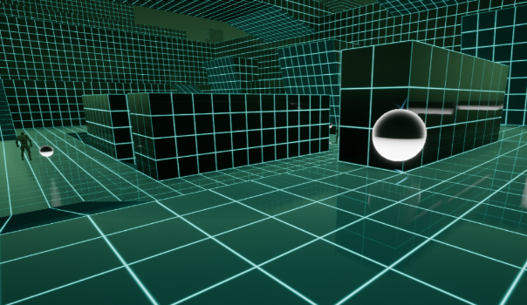

**Directions**

1. Download the Stealth Game example from the Marketplace. See the instructions above for more information**.**
2. Once loaded, play through the example (in the editor) a few times, making sure to thoroughly explore the map.
3. Think about the layout and the game mechanics present in the Stealth Game. What kind of relationship exists between them?
4. Sketch out your own level on the provided sheet.
5. Create a new Level asset and save it into the maps folder using the following naming convention: “*yourname*\_SGMap”.
6. Block out your design using BSP and simple static mesh primitives.
7. Do the following to your map:
   1. Add Nav Mesh Bounds Volume (to allow the AI to navigate).
   2. Add SGPawnBase for any guards you want to add. (If you would like them to patrol, add a patrol component and pathing points.)
   3. Add an SG Exit Actor (for the player to escape to).
   4. Add Player Starts for where the player will spawn.
   5. Set the GameMode to SGGameMode in the World Setting GameMode Override.
   6. Add SG Collectables to open up the exit when you’re done.
8. Have other members of the group try your map. Make a note of any feedback on the provided activity sheet.
9. Save your files into a zipped folder with the following naming convention: “*yourname\_*EX4B.zip”.

Activity Sheet 4B

|  |  |  |  |
| --- | --- | --- | --- |
| Name: |  | Date: |  |

Level Design (Sketch out your design ideas below.)

|  |  |  |  |
| --- | --- | --- | --- |
| Name: |  | Date: |  |

Feedback (Record any feedback in the space below.)

\_\_\_\_\_\_\_\_\_\_\_\_\_\_\_\_\_\_\_\_\_\_\_\_\_\_\_\_\_\_\_\_\_\_\_\_\_\_\_\_\_\_\_\_\_\_\_\_\_\_\_\_\_\_\_\_\_\_\_\_\_\_\_\_\_\_\_\_\_\_\_\_\_\_\_\_\_\_\_\_\_\_\_\_\_\_\_\_\_\_\_\_\_\_\_\_\_\_\_\_\_\_\_\_\_\_\_\_\_\_\_\_\_\_\_\_\_\_\_\_\_\_\_\_\_\_\_\_\_\_\_\_\_\_\_\_\_\_\_\_\_\_\_\_\_\_\_\_\_\_\_\_\_\_\_\_\_\_\_\_\_\_\_\_\_\_\_\_\_\_\_\_\_\_\_\_\_\_\_\_\_\_\_\_\_\_\_\_\_\_\_\_\_\_\_\_\_\_\_\_\_\_\_\_\_\_\_\_\_\_\_\_\_\_\_\_\_\_\_\_\_\_\_\_\_\_\_\_\_\_\_\_\_\_\_\_\_\_\_\_\_\_\_\_\_\_\_\_\_\_\_\_\_\_\_\_\_\_\_\_\_\_\_\_\_\_\_\_\_\_\_\_\_\_\_\_\_\_\_\_\_\_\_\_\_\_\_\_\_\_\_\_\_\_\_\_\_\_\_\_\_\_\_\_\_\_\_\_\_\_\_\_\_\_\_\_\_\_\_\_\_\_\_\_\_\_\_\_\_\_\_\_\_\_\_\_\_\_\_\_\_\_\_\_\_\_\_\_\_\_\_\_\_\_\_\_\_\_\_\_\_\_\_\_\_\_\_\_\_\_\_\_\_\_\_\_\_\_\_\_\_\_\_\_\_\_\_\_\_\_\_\_\_\_\_\_\_\_\_\_\_\_\_\_\_\_\_\_\_\_\_\_\_\_\_\_\_\_\_\_\_\_\_\_\_\_\_\_\_\_\_\_\_\_\_\_\_\_\_\_\_\_\_\_\_\_\_\_\_\_\_\_\_\_\_\_\_\_\_\_\_\_\_\_\_\_\_\_\_\_\_\_\_\_\_\_\_\_\_\_\_\_\_\_\_\_\_\_\_\_\_\_\_\_\_\_\_\_\_\_\_\_\_\_\_\_\_\_\_\_\_\_\_\_\_\_\_\_\_\_\_\_\_\_\_\_\_\_\_\_\_\_\_\_\_\_\_\_\_\_\_\_\_\_\_\_\_\_\_\_\_\_\_\_\_\_\_\_\_\_\_\_\_\_\_\_\_\_\_\_\_\_\_\_\_\_\_\_\_\_\_\_\_\_\_\_\_\_\_\_\_\_\_\_\_\_\_\_\_\_\_\_\_\_\_\_\_\_\_\_\_\_\_\_\_\_\_\_\_\_\_\_\_\_\_\_\_\_\_\_\_\_\_\_\_\_\_\_\_\_\_\_\_\_\_\_\_\_\_\_\_\_\_\_\_\_\_\_\_\_\_\_\_\_\_\_\_\_\_\_\_\_\_\_\_\_\_\_\_\_\_\_\_\_\_\_\_\_\_\_\_\_\_\_\_\_\_\_\_\_\_\_\_\_\_\_\_\_\_\_\_\_\_\_\_\_\_\_\_\_\_\_\_\_\_\_\_\_\_\_\_\_\_\_\_\_\_\_\_\_\_\_\_\_\_\_\_\_\_\_\_\_\_\_\_\_\_\_\_\_\_\_\_\_\_\_\_\_\_\_\_\_\_\_\_\_\_\_\_\_\_\_\_\_\_\_\_\_\_\_\_\_\_\_\_\_\_\_\_\_\_\_\_\_\_\_\_\_\_\_\_\_\_\_\_\_\_\_\_\_\_\_\_\_\_\_\_\_\_\_\_\_\_\_\_\_\_\_\_\_\_\_\_\_\_\_\_\_\_\_\_\_\_\_\_\_\_\_\_\_\_\_\_\_\_\_\_\_\_\_\_\_\_\_\_\_\_\_\_\_\_\_\_\_\_\_\_\_\_\_\_\_\_\_\_\_\_\_\_\_\_\_\_\_\_\_\_\_\_\_\_\_\_\_\_\_\_\_\_\_\_\_\_\_\_\_\_\_\_\_\_\_\_\_\_\_\_\_\_\_\_\_\_\_\_\_\_\_\_\_\_\_\_\_\_\_\_\_\_\_\_\_\_\_\_\_\_\_\_\_\_\_\_\_\_\_\_\_\_\_\_\_\_\_\_\_\_\_\_\_\_\_\_\_\_\_\_\_\_\_\_\_\_\_\_\_\_\_\_\_\_\_\_\_\_\_\_\_\_\_\_\_\_\_\_\_\_\_\_\_\_\_\_\_\_\_\_\_\_\_\_\_\_\_\_\_\_\_\_\_\_\_\_\_\_\_\_\_\_\_\_\_\_\_\_\_\_\_\_\_\_\_\_\_\_\_\_\_\_\_\_\_\_\_\_\_\_\_\_\_\_\_\_\_\_\_\_\_\_\_\_\_\_\_\_\_\_\_\_\_\_\_\_\_\_\_\_\_\_\_\_\_\_\_\_\_\_\_\_\_\_\_\_\_\_\_\_\_\_\_\_\_\_\_\_\_\_\_\_\_\_\_\_\_\_\_\_\_\_\_\_\_\_\_\_\_\_\_\_\_\_\_\_\_\_\_\_\_\_\_\_\_\_\_\_\_\_\_\_\_\_\_\_\_\_\_\_\_\_\_\_\_\_\_\_\_\_\_\_\_\_\_\_\_\_\_\_\_\_\_\_\_\_\_\_\_\_\_\_\_\_\_\_\_\_\_\_\_\_\_\_\_\_\_\_\_\_\_\_\_\_\_\_\_\_\_\_\_\_\_\_\_\_\_\_\_\_\_\_\_\_\_\_\_\_\_\_\_\_\_\_\_\_\_\_\_\_\_\_\_\_\_\_\_\_\_\_\_\_\_\_\_\_\_\_\_\_\_\_\_\_\_\_\_\_\_\_\_\_\_\_\_\_\_\_\_\_\_\_\_\_\_\_\_\_\_\_\_\_\_\_\_\_\_\_\_\_\_\_\_\_\_\_\_\_\_\_\_\_\_\_\_\_\_\_\_\_\_\_\_\_\_\_\_\_\_\_\_\_\_\_\_\_\_\_\_\_\_\_\_\_\_\_\_\_\_\_\_\_\_\_\_\_\_\_\_\_\_\_\_\_\_\_\_\_\_\_\_\_\_\_\_\_\_\_\_\_\_\_\_\_\_\_\_\_\_\_\_\_\_\_\_\_\_\_\_\_\_\_\_\_\_\_\_\_\_\_\_\_\_\_\_\_\_\_\_\_\_\_\_\_\_\_\_\_\_\_\_\_\_\_\_\_\_\_\_\_\_\_\_\_\_\_\_\_\_\_\_\_\_\_\_\_\_\_\_\_\_\_\_\_\_\_\_\_\_\_\_\_\_\_\_\_\_\_\_\_\_\_\_\_\_\_\_\_\_\_\_\_\_\_\_\_\_\_\_\_\_\_\_\_\_\_\_\_\_\_\_\_\_\_\_\_\_\_\_\_\_\_\_\_\_\_\_\_\_\_\_\_\_\_\_\_\_\_\_\_\_\_\_\_\_\_\_\_\_\_\_\_\_\_\_\_\_\_\_\_\_\_\_\_\_\_\_\_\_\_\_\_\_\_\_\_\_\_\_\_\_\_\_\_\_\_\_\_\_\_\_\_\_\_\_\_\_\_\_\_\_\_\_\_\_\_\_\_\_\_\_\_\_\_\_\_\_\_\_\_\_\_\_\_\_\_\_\_\_\_\_\_\_\_\_\_\_\_\_\_\_\_\_\_\_\_\_\_\_\_\_\_\_\_\_\_\_\_\_\_\_\_\_\_\_\_\_\_\_\_\_\_\_\_\_\_\_\_\_\_\_\_\_\_\_\_\_\_\_\_\_\_\_\_\_\_\_\_\_\_\_\_\_\_\_\_\_\_\_\_\_\_\_\_\_\_\_\_\_\_\_\_\_\_\_\_\_\_\_\_\_\_\_\_\_\_\_\_\_\_\_\_\_\_\_\_\_\_\_\_\_\_\_\_\_\_\_\_\_\_\_\_\_\_\_\_\_\_\_\_\_\_\_\_\_\_\_\_\_\_\_\_\_\_\_\_\_\_\_\_\_\_\_\_\_\_\_\_\_\_\_\_\_\_\_\_\_\_\_\_\_\_\_\_\_\_\_\_\_\_\_\_\_\_\_\_\_\_\_\_\_\_\_\_\_\_\_\_\_\_\_\_\_\_\_\_\_\_\_\_\_\_\_\_\_\_\_\_\_\_\_\_\_\_\_\_\_\_\_\_\_\_\_\_\_\_\_\_\_\_\_\_\_\_\_\_\_\_\_\_\_\_\_\_\_\_\_\_\_\_\_\_\_\_\_\_\_\_\_\_\_\_\_\_\_\_\_\_\_\_\_\_\_\_\_\_\_\_\_\_\_\_\_\_\_\_\_\_\_\_\_\_\_\_\_\_\_\_\_\_\_\_\_\_\_\_\_\_\_\_\_\_\_\_\_\_\_\_\_\_\_\_\_\_\_\_\_\_\_\_\_\_\_\_\_\_\_\_\_\_\_\_\_\_\_\_\_\_\_\_\_\_\_\_\_\_\_\_\_\_\_\_\_\_\_\_\_\_\_\_\_\_\_\_\_\_\_\_\_\_\_\_\_\_\_\_\_\_\_\_\_\_\_\_\_\_\_\_\_\_\_\_\_\_\_\_\_\_\_\_\_\_\_\_\_\_\_\_\_\_\_\_\_\_\_\_\_\_\_\_\_\_\_\_\_\_\_\_\_\_\_\_\_\_\_\_\_\_\_\_\_\_\_\_\_\_\_\_\_\_\_\_\_\_\_\_\_\_\_\_\_\_\_\_\_\_\_\_\_\_\_\_\_\_\_\_\_\_\_\_\_\_\_\_\_\_\_\_\_\_\_\_\_\_\_\_\_\_\_\_\_\_\_\_\_\_\_\_\_\_\_\_\_\_\_\_\_\_\_\_\_\_\_\_\_\_\_\_\_\_\_\_\_\_\_\_\_\_\_\_\_\_\_\_\_\_\_\_\_\_\_\_\_\_\_\_\_\_\_\_\_\_\_\_\_\_\_\_\_\_\_\_\_\_\_\_\_\_\_\_\_\_\_\_\_\_\_\_\_\_\_\_\_\_\_\_\_\_\_\_\_\_\_\_\_\_\_\_\_\_\_\_\_\_\_\_\_\_\_\_\_\_\_\_\_\_\_\_\_\_\_\_\_\_\_\_\_\_\_\_\_\_\_\_\_\_\_\_\_\_\_\_\_\_\_\_\_\_\_\_\_\_\_\_\_\_\_\_\_\_\_\_\_